Daniel Jericho Estaris BSIT-3B INFOT6 Lab 5 Documentations and Questions
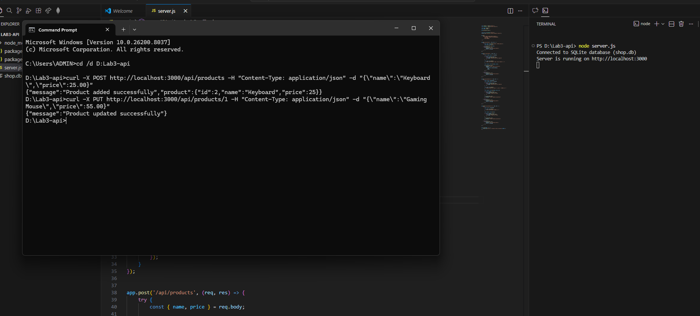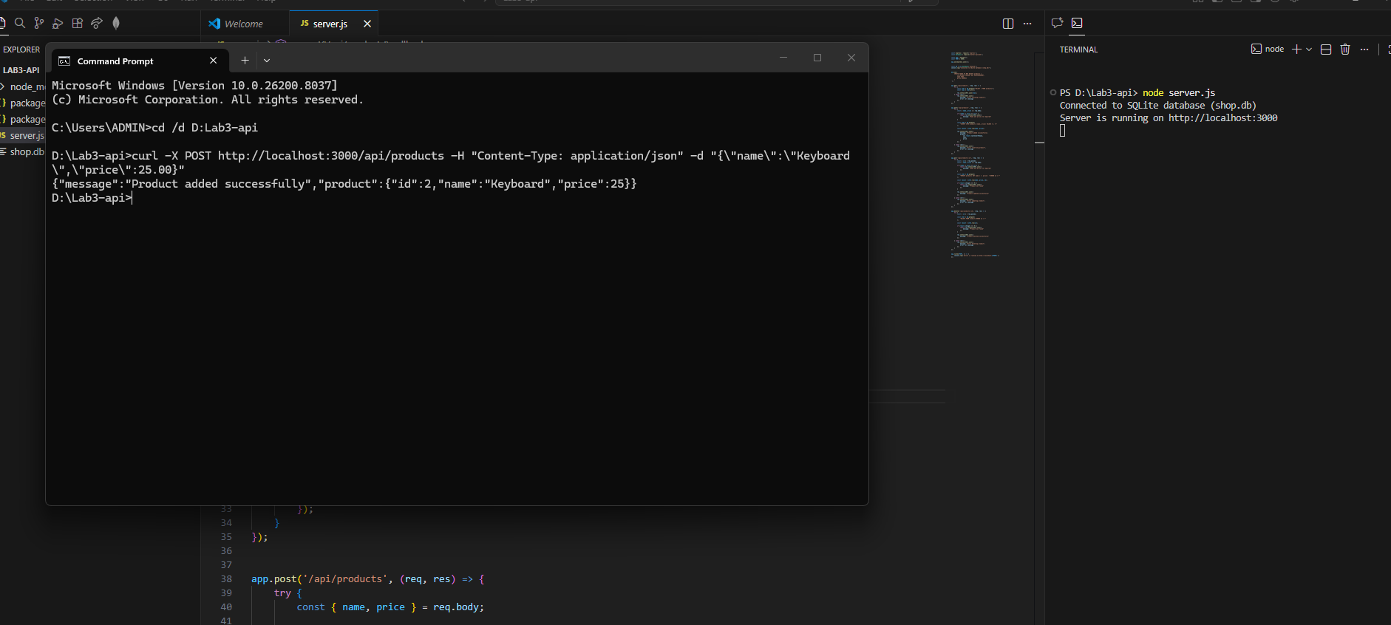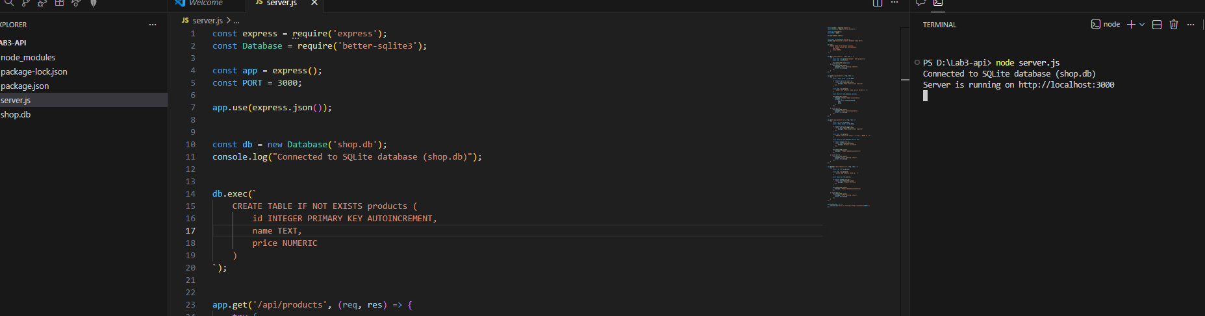

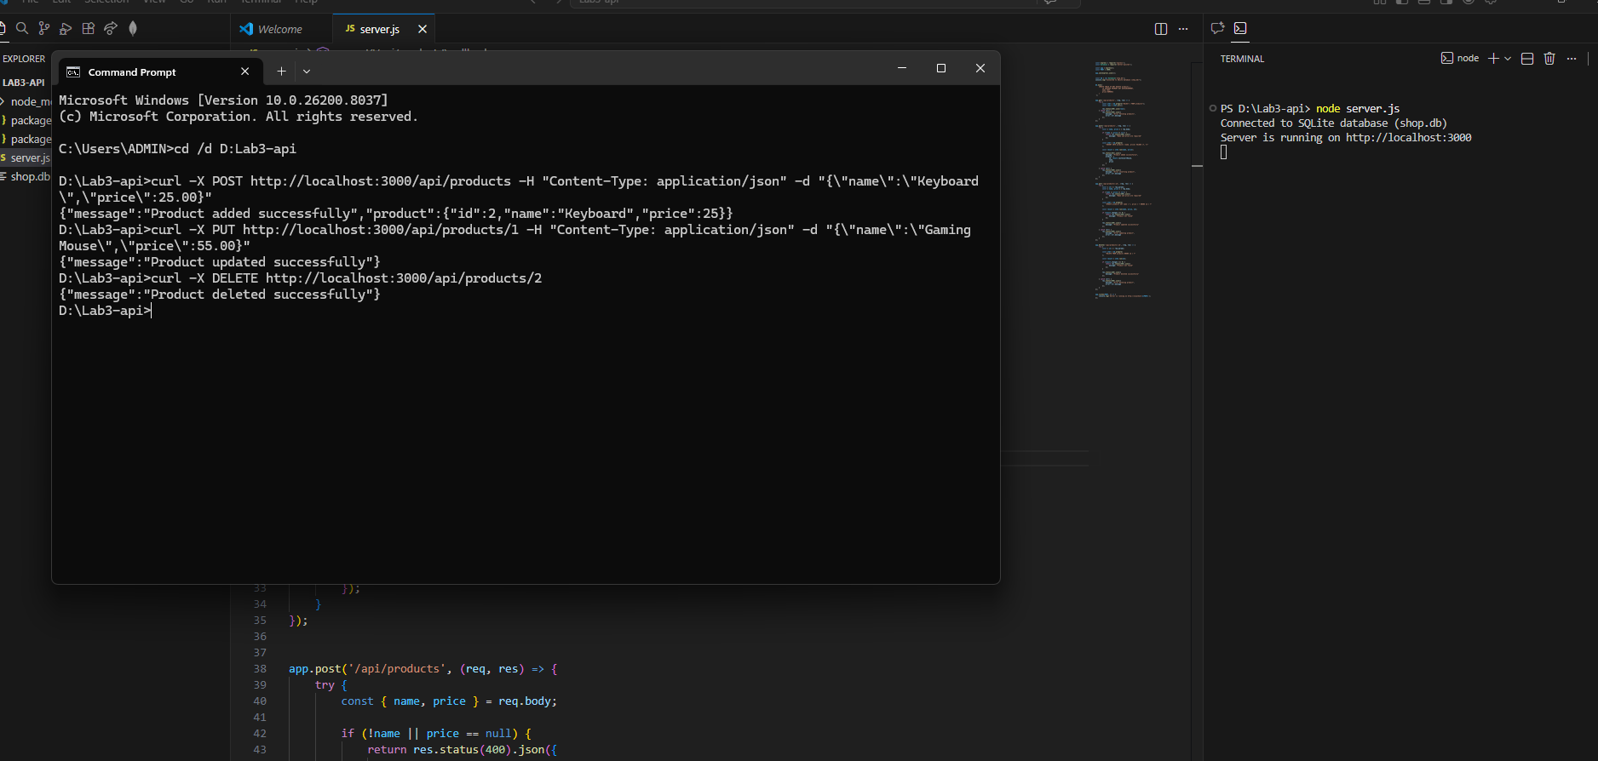

Questions
1. POST is not as strict as PUT as it is just used to submit data, while PUT is used to update already existing data. Identifying the exact data to be update and or replaced and then sends the new data.

2. In the scenario that the ID does not exist it is always better to receive a 404 error as opposed to just getting a success message so that we can know immediately and wont have to spend hours trying to find a problem that isn’t there.

3. If we were to connect a mobile or React app, this CRUD api would serve as the backend part of said app.

